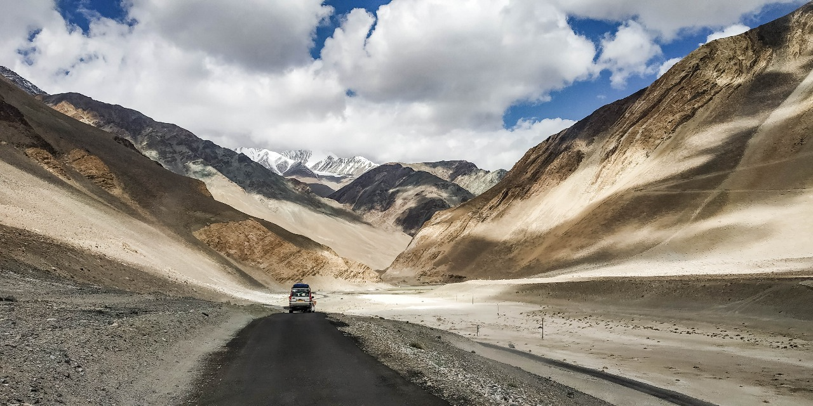
Ladakh – The Story That Started Everything

Hey everyone, I’m back! And honestly, I never thought I’d miss photography this much. It has been a part of me ever since I discovered my passion for it, and I’ve always wanted to do more—push my limits, chase new frames, and tell stories through my lens.
It all started back in my first year of college. What began as just an extracurricular activity quickly turned into something much bigger. Before I knew it, I was exploring every corner of my city, searching for untold stories to capture. I traveled to the farthest, most rugged parts of the country, just to take that one perfect shot—like a souvenir, a piece of a place to keep with me forever. And the journey that ignited it all? My first trip to Ladakh. That’s where my love for photography truly took flight.
But then, life happened. In the blink of an eye, those frequent escapes into photography turned into rare moments. Weekly photo walks became monthly, then yearly. The challenges I set for myself, the little creative projects, the thrill of capturing something new—all of it started slipping away. And I missed it. I missed the rush, the adventure, the way photography made me see the world differently.
But no more. I’ve decided to make time. To pick up my camera again, not just to take pictures, but to share my stories—the beauty I’ve seen, the experiences that shaped me, and the moments that made me feel alive.
I used to think my experiences were treasures meant just for me. But someone once told me that by sharing them, I could inspire others—to explore, to appreciate, and to respect the cultures and landscapes that make our world so incredible. So that’s what I’m going to do. I’ll show you what I’ve seen, tell you what not to miss, and maybe, just maybe, help you fall in love with the world the way I did.
To those who stuck around despite my absence, thank you. I promise to be more present, to bring you along on my adventures, and to share my world through my lens once again.
"Yeh hai mera nazariya."

